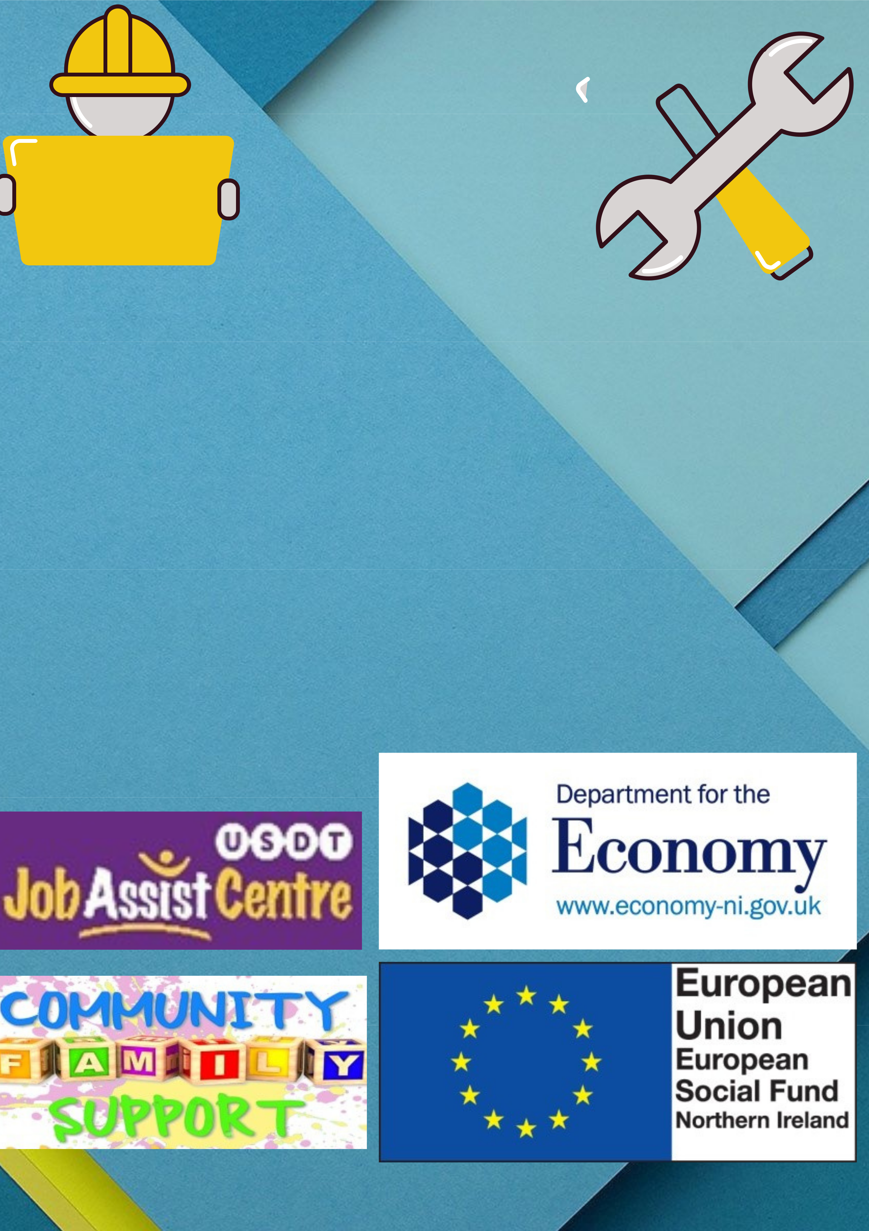
CSR card 

The card needed for Health & Safety on any construction site

Are you unemployed or working less than 16 hours a week and interested in getting your CSR card??

If so, why not give us a call on 07432556680 Or 02890322003 or even send us a text.

Asking for Charlene or Nichola with #CSR

Community Family Support Programme is a free voluntary employability programme with the wraparound of family support working for the whole family to reduce barriers

to education, trainingand employment.

This Project is part funded through the Northern Ireland European Social Fund Programme 2014- 2020 and the Department for the Economy

