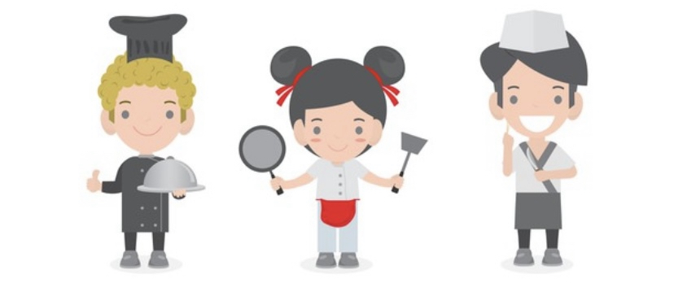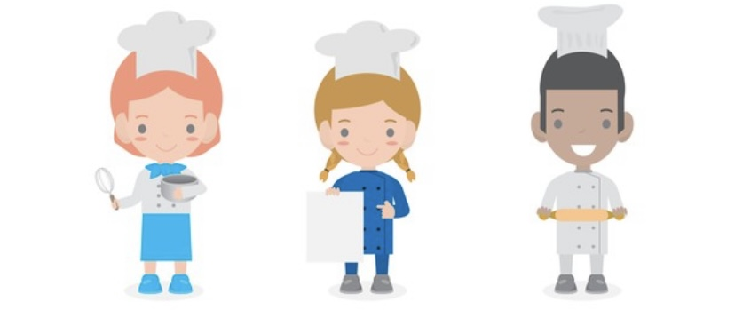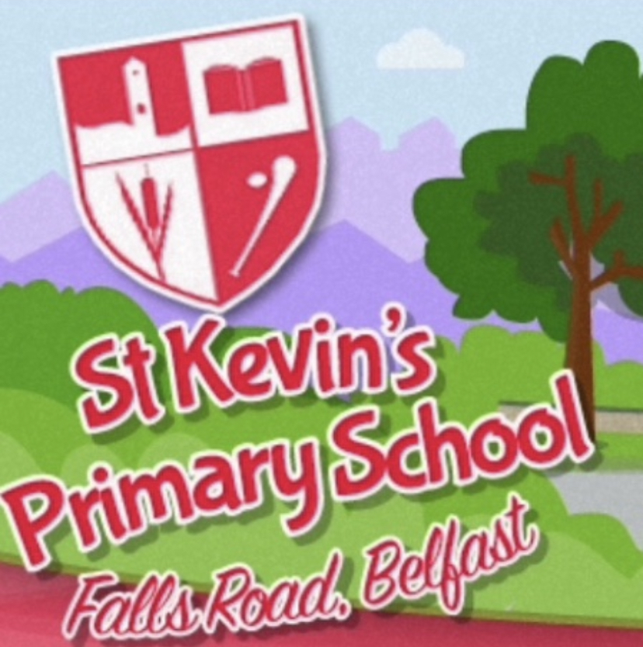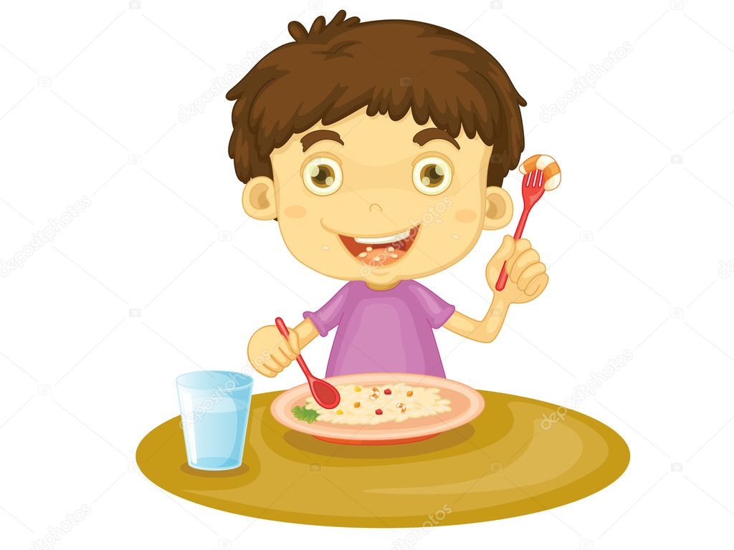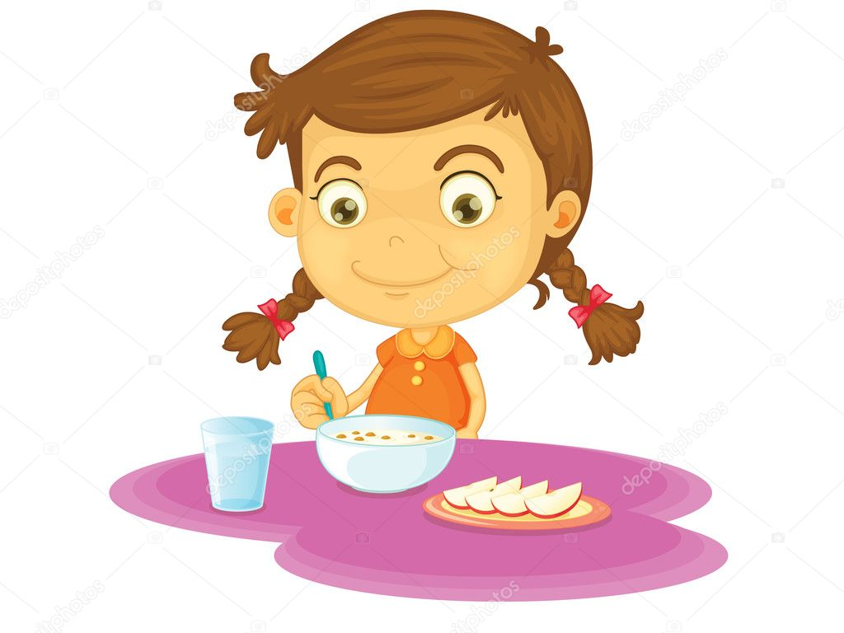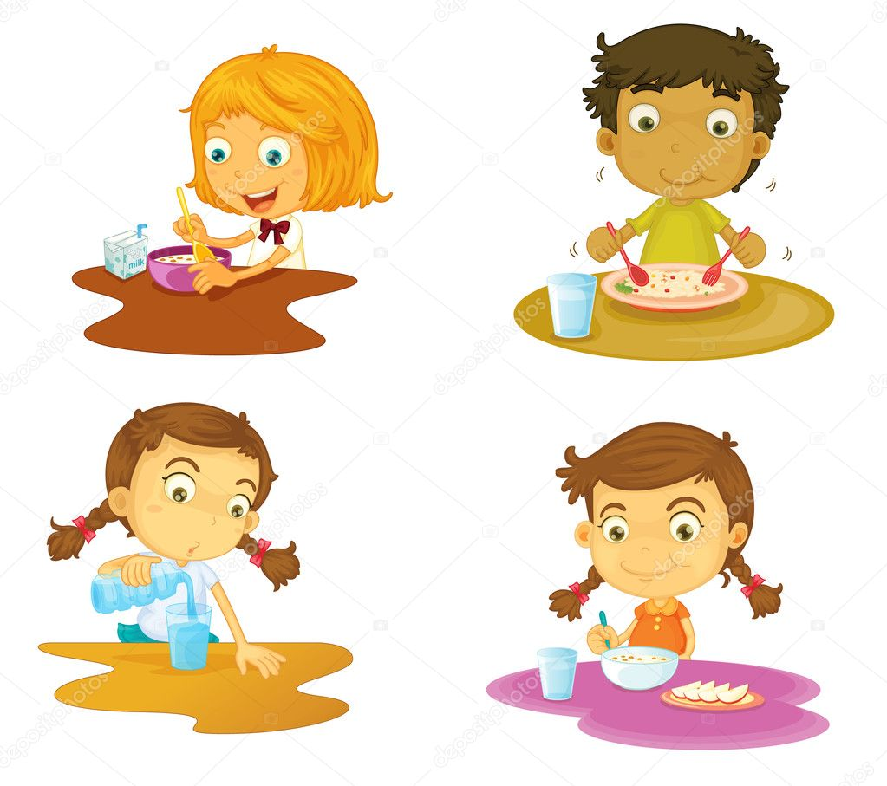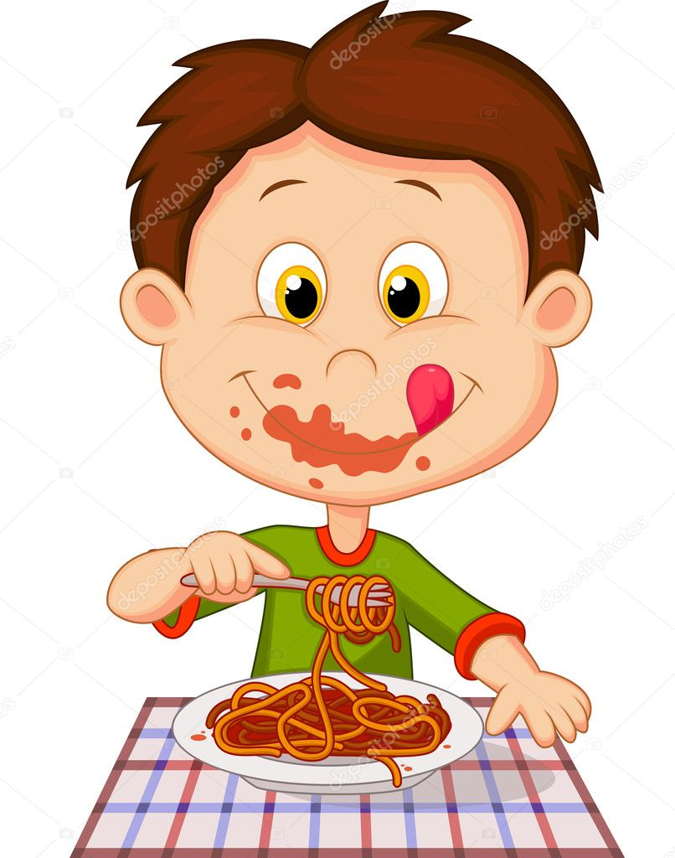

**Monday, 05 September 2022**

**Halal Sausages**

**Baked Beans & Creamed Potatoes**

**Ice-Cream Tubs**

**~**

**Tuesday, 06 September 2022**

**Halal ChickenNuggets**

**Peas & Creamed Potatoes**

**Sponge Cake**

**~**

**Wednesday, 07 September 2022**

**Halal Chicken Roast**

**Diced Carrots & Roast Potatoes**

**Mixed Fruit Yogurt**

**~**

**Thursday, 08 September 2022**

**Halal Savoury Mince**

**Peas & Creamed Potatoes**

**Homemade Sponge Cake**

**~**

**Friday, 09 September 2022**

**Fishfingers**

**Baked Beans & Chipped Potatoes**

**Fruit and custard**

St Kevin’s Lunch Menu



**Monday, 12 September 2022**

**Halal Beefburger in a Bap**

**Chipped Potatoes**

**Cookie or Muffin**

**~**

**Tuesday, 13 September 2022**

**Halal Chicken Curry**

**With Boiled Rice & Naan Bread**

**Fruit and custard**

**~**

**Wednesday, 14 September 2022**

**Fishfingers**

**Peas & Creamed Potatoes**

**Mixed Fruit Yogurt**

**~**

**Thursday, 15 September 2022**

**Roast Breast of Halal Chicken**

**Gravy, Carrots / Parsnip**

**Creamed & Roast Potatoes**

**Flakemeal Biscuit or Cookie**

**~**

**Friday, 16 September 2022**

**Halal Chicken Breast Nuggets**

**Baked Beans & Chipped Potatoes**

**Ice-Cream Tubs**

St Kevin’s Lunch Menu



**Monday, 19 September 2022**

**Halal Stew**

**Selection of Bread**

**Mixed Fruit Yogurt**

**~**

**Tuesday, 20 September 2022**

**Halal Chicken Curry**

**With Boiled Rice & Naan Bread**

**Homemade Sponge Cake**

**~**

**Wednesday, 21 September 2022**

**Fishfingers**

**Baked Beans & Chipped Potatoes**

**Ice-Cream Tubs**

**~**

**Thursday, 22 September 2022**

**Halal Roast chicken in gravy**

**Cabbage, Creamed & Roast Potatoes**

**Flakemeal Biscuit or Cookie**

**~**

**Friday, 23 September 2022**

**Vegetable soup / Halal Hot-Dogs**

**Frozen Fruit Yoghurts**

St Kevin’s Lunch Menu



**Monday, 26 September 2022**

**Halal Sausages**

**Baked Beans & Creamed Potatoes**

**Muffin, Flakemeal Biscuit or Cookie**

**~**

**Tuesday, 27 September 2022**

**Halal Chicken Breast Nuggets**

**Peas & Creamed Potatoes**

**Homemade Sponge Cake**

**~**

**Wednesday, 28 September 2022**

**Roast Breast of Halal Chicken**

**Gravy, Diced Turnip & Creamed Potatoes**

**Ice-Cream Tubs**

**~**

**Thursday, 29 September 2022**

**Halal Spaghetti Bolognaise**

**Breads inc. Garlic Bread**

**Fruit and custard**

**~**

**Friday, 30 September 2022**

**Fishfingers**

**Baked Beans & Chipped Potatoes**

**Strawberry / Raspberry Mousse**

St Kevin’s Lunch Menu